The below figure was found using the code in the draft and matches with the plot in the draft.

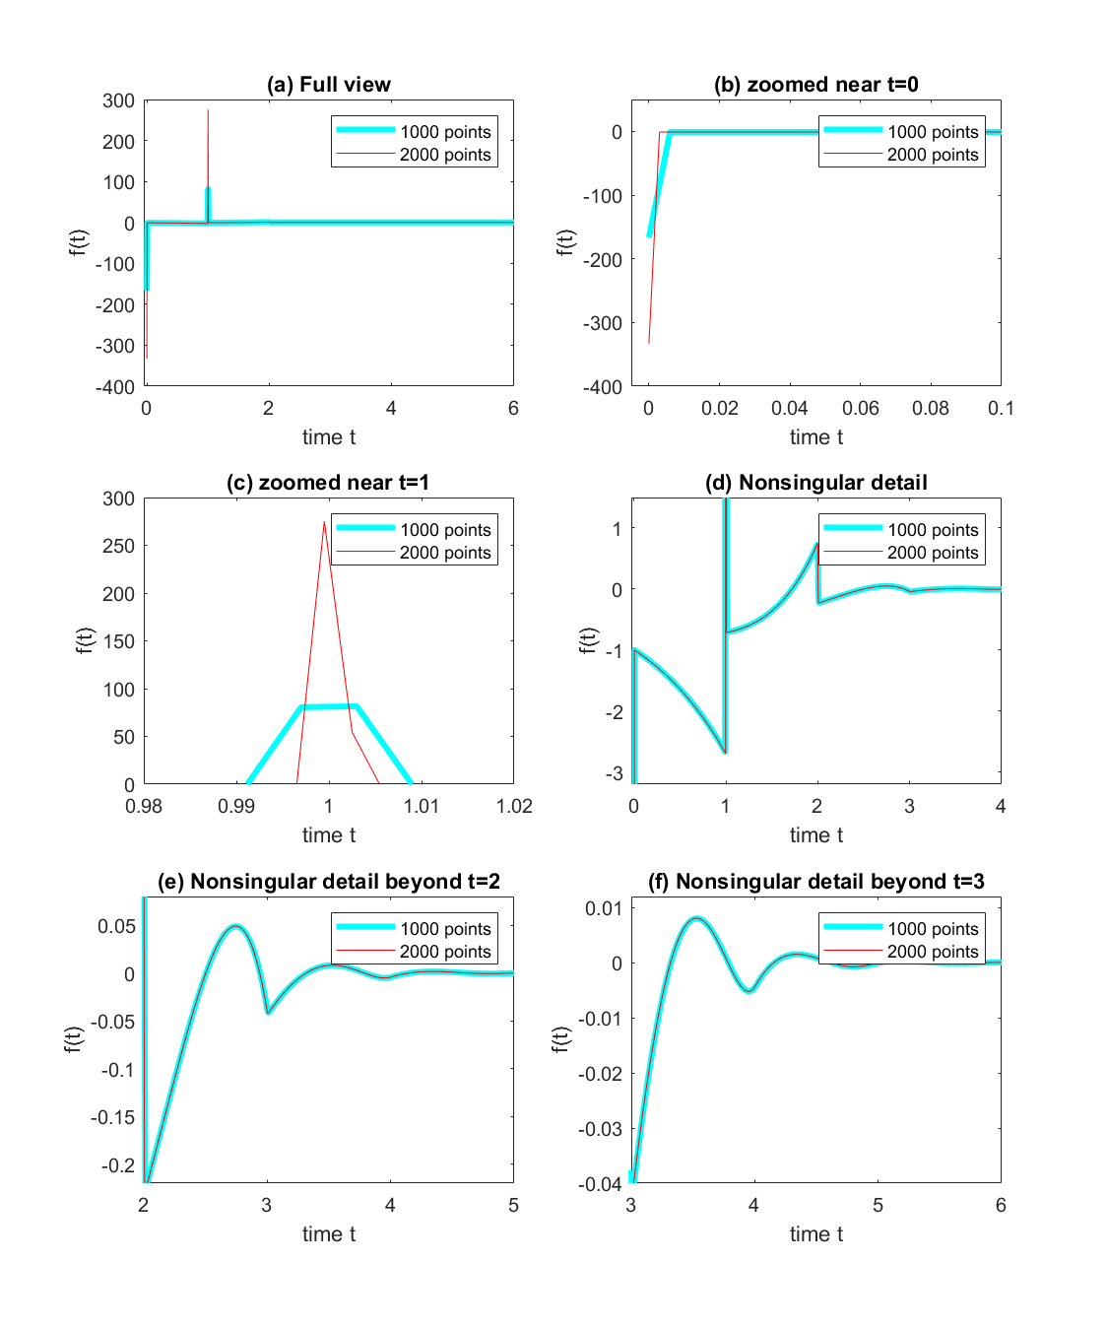

Figure 1

The polynomials were obtained using Matlab’s polyfit function. p1 represents polynomial in the interval [0,1] and similarly for other intervals respectively. The following are the polynomials obtained.

$$p_{1}\left(t\right)= -0.0137 t^{5} -0.0345 t^{4} -0.1692 t^{3} -0.4960 t^{2} -0.9956 t -0.9970 \\ p_{2}\left(t\right)= 0.0658 t^{5}-0.2321{ t}^{4}+0.6696 t^{3} -0.6434 t^{2} 0.1584 t -0.7333 \\ p_{3}\left(t\right)= -0.1230 t^{5}+ 1.1804 t^{4} -4.7502{ t}^{3}+10.1287{ t}^{2}-10.9628 t +4.2296$$

$$p_{4}\left(t\right)= 0.1091 t^{5} -1.7158 t^{4}+10.7465 t^{3} -33.6882 t^{2}+53.2785 t-34.3780 \\ p_{5}\left(t\right)= -0.0412 t^{5}+ 0.9092{ t}^{4}-7.9743{ t}^{3}+ 34.6856 t^{2} -74.7490t + 63.7710 \\ p_{6}\left(t\right)= 0.0011 t^{5} -0.0407t^{4}+ 0.5696{ t}^{3}-3.8204{ t}^{2}+12.4353 t -15.8333$$

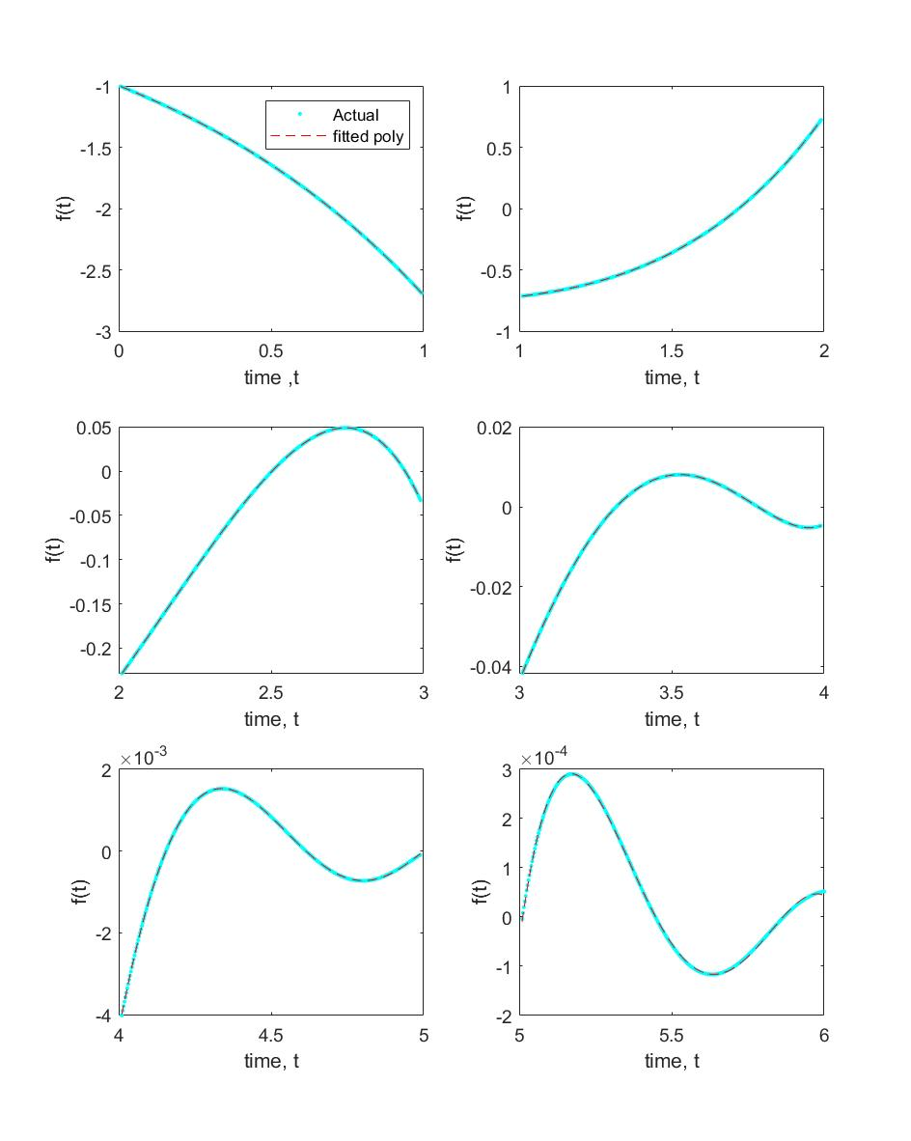  
Figure 2- Actual and fitted polynomials

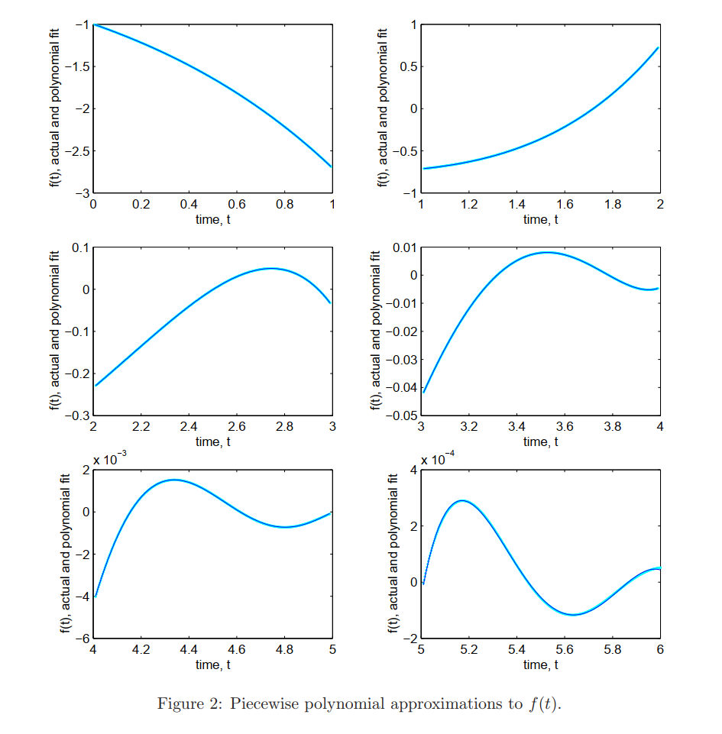

Plot in the draft for the polynomials.

The discrete delayed feedbacks are only considered at t=0 and t=1, distributed delayed feedback are considered using integrals. The following DDE is obtained- $$\dot{x\left(t\right)}= -x\left(t\right)+x\left(t-1\right)+\int_{0}^{1}{p_{1}\left(τ\right)x\left(t-τ\right) dτ}+\int_{1}^{2}{p_{2}\left(τ\right)x\left(t-τ\right) dτ}+\int_{2}^{3}{p_{3}\left(τ\right)x\left(t-τ\right) dτ}+\int_{3}^{4}{p_{4}\left(τ\right)x\left(t-τ\right) dτ}+\int_{4}^{5}{p_{5}\left(τ\right)x\left(t-τ\right) dτ}+\int_{5}^{6}{p_{6}\left(τ\right)x\left(t-τ\right) dτ}$$

Then substituting *x(t)* = *eλt,* the following characteristic equation is obtained-

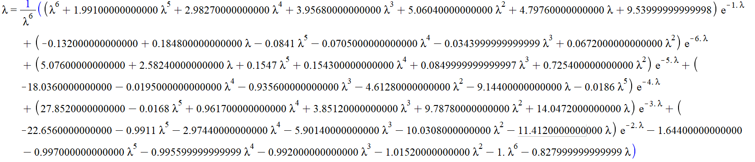

This characteristic equation is not the same as that in the draft as we get different roots.(I checked the expanded form of above with that in the draft some terms don’t match)

The following are the roots of the above equation-

